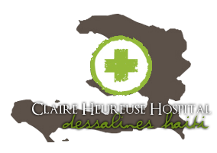

To Whom It May Concern,

We are writing to welcome you and thank you for your desire to be involved with medical missions in Haiti. As a group leader, you have a great privilege and a great responsibility. One of these responsibilities is specifically AIDS awareness training in which we request that you involve all team (including non-medical) personnel.

Specifically, we would like you to inform all team members of the truths and myths concerning working with individuals who have AIDS and other blood borne diseases. We would also like you to teach all personnel the proper handling of all potentially contaminated bodily fluids, needles etc.

In addition, we would request that only full time medical personnel be involved in higher risk activities, such as surgery. We want this experience to be a positive, rather than a tragic, experience for all.

Haiti Healthcare Advocates
Medical Division

